LEWISHAM GROUP SixIntoSeven 2022
Data Protection Impact Assessment

Submitting controller details
Name of controller
Subject/title of DPO
Name of controller contact

Step 1: Identify the need for a DPIA
Explain broadly what project aims to achieve and what type of processing it involves. You may find it helpful to refer or link to other documents, such as a project proposal. Summarise why you identified the need for a DPIA.
Participating Schools use SixIntoSeven to, transfer pupil information from a primary to a secondary school, through a secure, cloud-based portal. Askeddi Ltd (t/a askEddi) have developed the portal (SixIntoSeven) to deliver year 6 to year 7 transition information in a safe and secure way.
Primary schools will manually upload their expected year 6 pupil list (full name and Unique Pupil Number) onto the portal as a CSV file, and record relevant pupil information into the “Pupil Information” form by primary school staff.
Secondary schools will manually upload their expected year 7 pupil list (full name and Unique Pupil Number) onto the portal as a CSV file.
Through a matching process in the system, a requesting secondary school’s pupil identifier made up of the Unique Pupil Number (UPN) will be used. This will identify a corresponding record provided by a primary school and provide the data in the secondary schools’ dashboard.
The portal will allow a download to a CSV file for secondary school use.
The data provided by the primary school will include pastoral information and attainment data. This allows the secondary school to prepare for the start of the new academic year, support curriculum design and identify learning needs of the year 7 cohort without the need for immediate testing to form a baseline.

Step 2: Describe the processing
Describe the nature of the processing: how will you collect, use, store and delete data? What is the source of the data? Will you be sharing data with anyone? You might find it useful to refer to a flow diagram or other way of describing data flows. What types of processing identified as likely high risk are involved?
Further information can be found at https://sixintoseven.co.uk/about
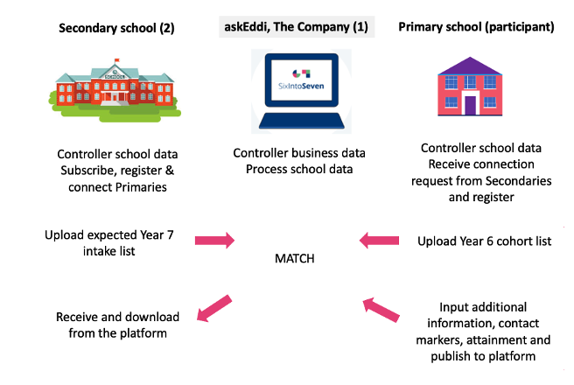

Describe the scope of the processing: what is the nature of the data, and does it include special category or criminal offence data? How much data will you be collecting and using? How often? How long will you keep it? How many individuals are affected? What geographical area does it cover?
SixIntoSeven is offered in 2022 to groups of schools to use for the primary and secondary schools for whom they purchase a SixIntoSeven annual subscription license.
The data collected and processed can be categorized as follows:
Business Data | School Data
•Users’ names and contact information (including email addresses);  •Details of interactions that the School has with the Company regarding the Product, together with any other information that the School and chooses to provide the Company with, for example, through correspondence and interactions with our customer and technical support teams  •Information collected automatically relating to the Product to include information eg a user’s IP address, device type, unique device identification numbers and login information, browser-type and version, time zone setting, operating system and platform, broad geographic location (e.g. country or city-level location) and other technical information;  •Information collected automatically relating to the Product about how a User’s device has interacted with the Site, including the pages accessed and links clicked, download errors, length of visits to certain pages, page interaction information, and methods used to browse away from any page. | From the School:  School name and contact information (including school postal address, phone number and email address)  - Student surname  - Student forename  - Student middle name  - UPN  - Class & year group  - Gender*  - Date of birth  - Age of leaving setting  - Primary start date  - Number of previous primary schools  - Names of previous primary schools  - Number of managed moves  - Free School Meals*  - Pupil premium*  - SEN *  - Names & year group of siblings attending secondary  - Social and friendship information-cohort of CYP  - Ethnicity*  - Languages understood and/or heard in the family*  - Languages spoken if EAL*  - Primary SEND need*  - Position in the family  - Parent/Carer 1 First name/Last name  - Parent/Carer 2 First name/Last name  - Child looked after*  - Exclusions (Fixed Term/Permanent) if yes, number of sessions  - Attendance percentage  - Child’s strengths and interests  - Details of any additional needs affecting the child’s Learning*  - Please describe Impact on Learning  - Professionals involved*  - Additional information to be forwarded to receiving school*  - Learning and development: Interventions and strategies  - Child known to social care*  - Referral to Early Help/MASH pending*  - Allocated Social Worker (if applicable) *  - Safeguarding (ONLY FOR CHILDREN on CP) *  - Any additional information for the secondary to know - and/or do you require a telephone conversation with us to discuss further?  - Key assessment information around English, Maths & Modern Foreign Languages.  Note: Can attach a SEND pdf file but only accessible by tier 2 users from secondary schools.

School data entered between March 2022 and March 2023 will not be retained beyond 31 July 2023.

Describe the context of the processing: what is the nature of your relationship with the individuals? How much control will they have? Would they expect you to use their data in this way? Do they include children or other vulnerable groups? Are there prior concerns over this type of processing or security flaws? Is it novel in any way? What is the current state of technology in this area? Are there any current issues of public concern that you should factor in? Are you signed up to any approved code of conduct or certification scheme (once any have been approved)?
In a normal year, Secondary Schools would receive Standard Assessment Test (SATs) results for their new Year 7 intake which they would review alongside a verity of transition forms and spreadsheets submitted be primary schools.
askEddi, in consultation with the Association of School and College Leaders (ASCL), Data Protection Experts and a steering group of school leaders, have developed a “one stop” platform to facilitate primary pupil transition information to be shared with their secondary colleagues, enabling appropriate planning and support for this cohort on entry into Year 7.
Building on the SixIntoSeven platform which allows primaries to simply and securely share pupil information and attainment information, SixIntoSeven can now support local authorities, school improvement services and school groups to deliver transition information alongside attainment data. Schools are able to setup their authorised school users up based on roles with assigned permissions. This level of security prohibits access to data classified as sensitive unless the user has been allocated to an appropriate role and who may download the data in a secondary school.
We are confident that parents expect there to be secure communication between schools to facilitate a seamless transition into secondary education, now more than ever.
askEddi are Cyber Essentials Certified.

Previous versions of the platform have not involved special category data, but the need for schools to have a complete picture and the ability to support the most vulnerable effectively and quickly at the commencement of their secondary education is paramount. Therefore, special category data, and sensitive information that will be treated as special category is present in this version. It is indicated with Asterix (*) above. These categories of information are such that that onward secondary setting must have access to. This platform provides timely and secure access to such, ensuring the minimization of disruption to support of vulnerable children and families during the transition process.
The secondary school must/will limit the access rights to the inbound information to a ‘need to know’ basis. Recommend SLT, DSL, transition/pastoral leads, data manager, SENCO, exams officer. These users will be given tier 2 permission access.

Describe the purposes of the processing: what do you want to achieve? What is the intended effect on individuals? What are the benefits of the processing – for you, and more broadly?
Transition from primary to secondary school at the end of Key Stage 2 is an important stage in a child’s learning journey. Through working with Schools, ASCL and policy expects, askEddi have identified a crucial gap in school processes when it comes to securely conveying information on pupil progress between schools.
In the spring and summer terms, both primary and secondary school use large amounts of time and resource to ensure that pupil information is passed from primary schools to secondary schools. This often takes the form of unprotected spreadsheets or printed forms which move between school departments. The types of information recorded may be personal or sensitive data and represents a risk to school.
Efforts to complete transition forms and paperwork add to workload at both primary and secondary level, and there has previously been no central point to collate and transmit pupil data related to transition.
SixIntoSeven is a cloud-based portal that allows schools to input and download data securely, only accessing the specific and relevant pupil information that they require to support pupils effectively. Primary schools complete one set of information in a consistent way: secondary schools receive one set of information in one place from all of their feeder primary schools.
Primary schools can be confident that they have entered enough information to allow their outgoing pupils to have a positive start at secondary school, and secondary schools can be confident that they are receiving accurate, consistent information from all of their feeder primaries to prepare for the pupils’ arrival.
Working in this way allows secondary schools to understand the pupils that will join them in the new school year and prepare effectively.

Step 3: Consultation process
Consider how to consult with relevant stakeholders: describe when and how you will seek individuals’ views – or justify why it’s not appropriate to do so. Who else do you need to involve within your organisation? Do you need to ask your processors to assist? Do you plan to consult information security experts, or any other experts?
The project is a collaboration between Lewisham Local Authority, school leaders and askEddi.

- Executive Leadership of the Lewisham Local Authority and School Leaders
- Leadership Group askEddi
- Derbyshire County Council Children’s Services (Education Data Hub - Data Protection Consultants)

Step 4: Assess necessity and proportionality
Describe compliance and proportionality measures, in particular: what is your lawful basis for processing? Does the processing actually achieve your purpose? Is there another way to achieve the same outcome? How will you prevent function creep? How will you ensure data quality and data minimisation? What information will you give individuals? How will you help to support their rights? What measures do you take to ensure processors comply? How do you safeguard any international transfers?
SixIntoSeven is a simple, secure web portal for primary and secondary schools for the compliant transfer of information to support pupils during Year 6 transition into Year 7.
Under the General Data Protection Regulation (GDPR), the lawful basis we generally rely on is Article 6(1)(b) for processing information. However, we feel it is helpful to set out the lawful bases that may be relied on by the schools that are sharing data with us. Schools should ensure that they have selected and documented the appropriate legal bases for their purposes. Data subjects should ascertain the school’s legal bases from the schools.
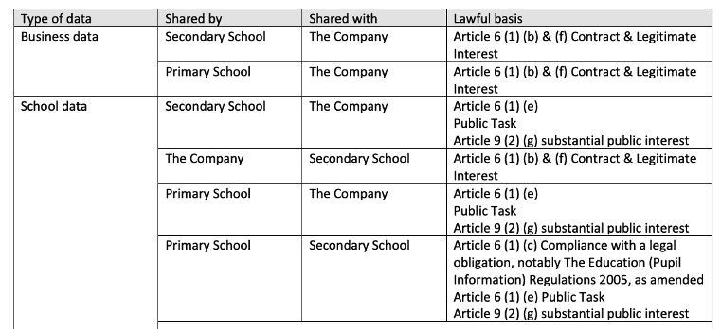
The data shared is required to carry out successful matching between schools. Then follows the additional information form and attainment grids.
Alternatives would be for this to be carried out directly between schools without the need for a third party ‘intermediary’. However, given the enormity of the transition task faced by schools, this provides a secure, efficient and consistent method that is GDPR compliant and is devised by school leaders.
Primary data input into SixIntoSeven takes two forms: the first is data already stored in the school’s MIS which can be extracted and uploaded via a csv file. The second is a manual input process completed by primary school staff to add transition information. Only data agreed fields agreed in advance may be shared, and the number of free-text fields is kept to the absolute minimum.
The following advice is issued to schools around data quality:
“Primary schools can alter any saved work. Once the data has been published and shared with secondary schools it is considered complete and final, and amendments must be requested by the askEddi support team. If it is a major problem, such as the UPNs are not matched up correctly to the names when uploaded to the portal, the data may be deleted and uploaded again.”

The following is included in the SixIntoSeven Platform License Agreement in relation to Data Subjects’ rights:
The Company shall provide all reasonable and timely assistance (including by appropriate technical and organisational measures) to the School to enable the School to respond to:
any request from a Data Subject to exercise rights under Applicable Data Protection Law (including its rights of access, correction, objection, erasure and data portability, as applicable); and
any other correspondence, enquiry or complaint received from a Data Subject, regulator or other third party in connection with the processing of the Data.

The following is included in the SixIntoSeven Platform License Agreement in relation to International Transfers:
The Company shall not transfer the Data (nor permit the Data to be transferred) outside of the European Economic Area ("EEA") unless it first takes such measures as are necessary to ensure any such transfer is in compliance with Applicable Data Protection Law.

Step 5: Identify, assess risks and mitigate risks
Stage | Risk Description | Potential impact | Owner | Priority | Prospect | Severity | Risk Level | Control Measures to Minimise Risk | New Level
GDPR | Inaccurate data provided. | Potential impact on individuals would include loss of confidentiality and potential embarrassment depending on nature of inaccurate data processed. | School | Immediate | 4 | 2 | M | Warning notice – The school takes full responsibility in the accuracy of the data provided in the upload stage. If a mistake is made a support team can be contacted to resolve the issue. | L
 | Platform processing more personal data than is required for their purpose.  Risks would include non-compliance (data being adequate, relevant & limited) as well as corporate risks (loss of credibility, enforcement action being taken, press coverage etc.) | Potential impact on individuals would include loss of confidentiality, potential embarrassment and potential harm depending on the nature of the data processed. | Askeddi | Immediate | 3 | 2 | L | Processing of data is only performed after Data Sharing Agreements have been signed, and the primary and secondary schools are connected through a participation agreement.  At any point before, during or after can the primary school withdraw its data (including amending, deleting records all or individual). | L
 | Passing of personal data to third parties not being authorised by school to receive the data. | Potential impact on individuals would include loss of confidentiality, potential embarrassment and even harm depending on the nature of the data transferred incorrectly. | Askeddi | Immediate | 3 | 2 | L | Clearly defined in the Data Sharing agreement and SixIntoSeven Platform License Agreement, the 3rd parties askEddi work with and that no pupil data is passed onto these 3rd parties. | L
 | School level data passed to third party for the wrong school through the platform. | Impact on the individuals include their data being seen by staff from another school, loss of confidentiality, potential embarrassment depending on the nature of the exposed personal data. | Askeddi | Immediate | 3 | 3 | M | Schools remain controllers and will manage the accuracy of the data they input to the system.  Use of UPN to match provides a 100% accuracy in the matching process as it is a unique number. | L
 | School staff email unprotected personal data to the instant chat tool.  This can occur when school staff see issues with the data and email the personal data to askEddi support staff for investigation. | Impact on individuals include their data being seen by integrator staff, the dangers inherent in emails being sent to incorrect recipients, loss of confidentiality, possible embarrassment or harm depending on the nature of the exposed data and its final recipient. | Askeddi | Immediate | 3 | 3 | M | askEddi support protocol is to support the school without needing to receive the personal data. All support will ensure no data is requested. | L
 | If a pupil does not attend the requesting secondary school and a further request is received by another secondary school. | The pupil data is shared with multiple authorised secondary schools. | School | Immediate | 5 | 2 | M | Secondary schools have the ability to remove the pupils that do not present at the school or change schools through the admission’s appeals process. Data Sharing Agreements are in place and schools remain compliant. Secondary schools adhere to the process. | L
 | A staff member is given access to special category data as specified in Annex A1 of the Data Sharing Agreement. | A school user has access to data that is not relevant to their role I.e. a class teacher or finance person. | School | Immediate | 3 | 2 | L | Field and section level security built into the additional information form to safeguard access to special category data. Role based permission configuration managed by the school. | L
 | School users being able to access special category data. | A staff member can view special category data. | Askeddi | Immediate | 1 | 1 | L | Field and section level security built into the additional information form to safeguard access to special category data. Role based permission configuration managed by the school. | L

Risks would include non-compliance (data being accurate and up to date) as well as corporate risks (loss of credibility, risks of enforcement action, press coverage etc.)

Step 6: Sign off and record outcomes
Item | Name/position/date | Notes
Measures approved by: |  | Integrate actions back into project plan, with date and responsibility for completion
Residual risks approved by: |  | If accepting any residual high risk, consult the ICO before going ahead
DPO advice provided: |  | DPO should advise on compliance, step 6 measures and whether processing can proceed
Summary of DPO advice:
DPO advice accepted or overruled by: |  | If overruled, you must explain your reasons
Comments:
Consultation responses reviewed by: |  | If your decision departs from individuals’ views, you must explain your reasons
Comments:
This DPIA will kept under review by: |  | The DPO should also review ongoing compliance with DPIA

